On a River: A History of North River, Massachusetts (2025)
Corrections and Additions
Available at https://www.lylenyberg.com/corrections-and-additions

On a River - Corrections and Additions
Lyle Nyberg, July 1, 2025; updated Sept. 4, Sept. 25, Oct. 27
www.lylenyberg.com

Summary. Below is a list of corrections and additions to the version of early April 2025, or later, of On a River. Some may have been incorporated in later paperback versions of the book available on Amazon. References are to page numbers in text except as noted. The book’s index has generally not been updated.

Please let me know of any more corrections or additions.

Following this list are items related to the book -- my notes on Zoning and on Benchmarks and Elevations, and Bill Richardson’s email on Great Green Island Remnants. Please let me know if you have any comments.

List of Corrections and Additions

Text

- 7 (at note 23 and following). As background for this discussion of rights in land, and the later discussion of shad and the rights to build dams, consider England’s Charter of the Forest. Issued in 1217, it supplemented the Magna Carta. It included this statement: “Henceforth every freeman, in his wood or on his land that he has in the forest, may with impunity make a mill, fish-preserve, pond, marl-pit, ditch, or arable in cultivated land outside coverts, provided that no injury is thereby given to any neighbour.” [The Charter of the Forest of King Henry III. St John's College, Oxford.]
- 14. Add paragraph as second from bottom: “Thus, the tides affect the entire river. Consider the long and mighty Mississippi, where tides affect its lower 100 miles, up to New Orleans. As noted, tides are complicated.” Add accompanying note (see below, page 231).
- 18. Add to note 62 (page 232): “See also William Falk, “One Family’s Relentless Pursuit of the Bony, Oily, Elusive Shad,” New York Times, April 26, 2025, https://www.nytimes.com/2025/04/26/nyregion/shad-fishing-new-jersey.html.”
- 19. Add to note 65: McPhee casts doubt on the legend that George Washington selected Valley Forge for his winter encampment because the Schuylkill River had shad that could feed the soldiers. The shad runs would not occur until late in the spring, after the soldiers left. However, salt shad was a common food for the soldiers. A veteran of Valley Forge had some delightful tales of salt shad in his diary. “Joseph Plumb Martin,” https://en.wikipedia.org/wiki/Joseph_Plumb_Martin.
- 45 (note 164). An outstanding discussion of salt haying, based on first-person experiences, is by Betsy H. Woodman, “Salt Haying, Farming, and Fishing in Salisbury, Massachusetts: The Life of Sherb Eaton (1900-1982),” Essex Institute Historical Collections, v.119 (July 1983), 165, https://catalog.hathitrust.org/Record/000681568. Thanks to John Stilgoe for alerting me to this article.
- 154. Remnants of the Great Green Island may exist as a rocky shoal and sand bar north of the spit at the end of Fourth Cliff, according to a persuasive email by Bill Richardson, May 12, 2025. Bill has explored the North River both on the water and above it. His work as pilot and photographer (with Gary Banks) appears on the front cover of this book and inside. He knows much more about shoals than I do. With his permission, his email is copied below, with images in color (resized to fit this document).
- 183, ch. 11 “Climate Change and Recent Studies.” Researchers were recently able to use satellite data on elevation to spot miles-long flood waves on waterways. “NASA-French Satellite Spots Large-Scale River Waves for First Time,” Jet Propulsion Laboratory, May 21, 2025, https://www.jpl.nasa.gov/news/nasa-french-satellite-spots-large-scale-river-waves-for-first-time/; Erin Blakemore, “Satellite measures river flow waves for the first time,” Washington Post, June 1, 2025, https://www.washingtonpost.com/science/2025/06/01/river-wave-satellite-flooding-data/. In addition, a recent study found that flood gauges (maintained by NOAA) often underestimate the true extent of flooding on land (covering roads) because they “do not measure rainfall runoff, groundwater contributions to flooding, or the effects of local drainage infrastructure.” Brady Dennis, “Many coastal communities are flooding more than we thought, researchers find. Researchers installed sensors inside stormwater drains and cameras above them in three North Carolina communities. They found a startling amount of flooding.” Washington Post, June 2, 2025 (quoting study), https://www.washingtonpost.com/climate-environment/2025/06/02/coastal-flooding-north-carolina/.

Notes

- 231 (add note). “Birdsfoot Delta Tides,” Rivergator.org, https://www.rivergator.org/river-log/birdsfoot-delta/introBD/pg/2/; “An Overview of the Mississippi River’s Saltwater Wedge,” US Army Corps of Engineers, https://www.mvn.usace.army.mil/Missions/Engineering/Stage-and-Hydrologic-Data/SaltwaterWedge/SaltwaterWedgeOverview/.
- 244, note 242. Add: Both the 1831 Scituate map and the 1838 Marshfield map are included and discussed in Joseph G. Garver, Surveying the Shore: Historic Maps of Coastal Massachusetts, 1600-1930 (Beverly, MA: Commonwealth Editions, 2006), 78-79, and 84-85.
- 248 (at note 320). Correct the title of Mark Monmonier’s book to Coast Lines (two words) here and in notes 328, 331, 332, 335, and 566.
- 249, note 327. Add: If you want to go deeper, see Aaron L. Shalowitz, Shore and Sea Boundaries: With Special Reference to the Interpretation and Use of Coast and Geodetic Survey Data (Washington, DC: US Government Printing Office, 1964), Pub. 10-1, in two volumes, https://nauticalcharts.noaa.gov/about/docs/history-of-coast-survey/shore-and-sea-boundaries-volume-two.pdf. In particular, on the history of early surveys, see Ch. 5 “Analysis and Interpretation of Hydrographic Surveys,” https://nauticalcharts.noaa.gov/publications/docs/shore-and-sea-boundaries/volume-2/cse-library-shalowitz-v2-p2-ch5.pdf. I particularly like this statement on pages 211-212: “Broadly speaking, hydrographic surveying may be defined as the process of developing upon a survey sheet all that portion of the earth’s surface which lies beneath the water. It aims to delineate with accuracy the submerged contour lines of channels, banks, and shoals, in a manner similar to features delineated by topography on the visible land, and to collect specimens of bottom material and water samples.” In note 2, Shalowitz says the earliest original survey filed in the Bureau archives is Register No. H-1961 (1817), a replotting of a survey of Boston Harbor.
- 256, note 481. Add: See also the trespass case brought in 1651in which Morris Truant threatened a person hired by Joseph Tilden to mow grass on “Hatches Iland,” reported by John R. Stilgoe, “A New England Coastal Wilderness,” Geographical Review, vol. 71, no. 1 (January 1981), 33-50, at 42, https://doi.org/10.2307/214550, citing Nathaniel B. Shurtleff, ed., Records of the Colony of New Plymouth (8 vols.) (Boston: William White, 1857), 1:56.
- 257, note 486. Add: For a 1968 aerial photo of Trouant Island, see CGL-139(?) on file in Scituate Town Archives, copy at my website, bottom of page, https://www.lylenyberg.com/copy-of-ditches.

Other

- My article on Canals of the North River was published in the Summer 2025 edition of the Norwell Historical Society's newsletter North River Packet. Go to https://norwellhistoricalsociety.org/newsletters%3A-2020-2025.
- View this fabulous aerial video of the North River, here.
- You may also like Robert Macfarlane's latest book, Is a River Alive? (New York: W. W. Norton, 2025).

Zoning
Lyle Nyberg, June 18, 2025

Thanks to Scituate Town Archives, I discovered an old zoning map that is instructive on the relationship between people and our environment.

The map is titled Supplementary Zoning Map, dated May 18, 1953. It was prepared by B. Allen Benjamin, Municipal Planning Consultant. He was a member (as of 1943) of the American Institute of Planners. He consulted for a number of Massachusetts municipalities.

The map supplements the town zoning by-laws, which had been adopted by 1940. These provide rules on permitted uses in each zone. The map has notes on town meeting changes to the by-laws up to 1964.

The map is in poor condition. It is so faded that it is nearly unreadable. When unrolled, its surface is like a washboard, producing zebra stripes when photographed. My photos had to be extensively processed in Photoshop to reveal details.

The map is large, covering a good part of an eight-person conference table. It is drawn on beige paper that is frayed or ripped at some edges. It appears to be hand-drawn, showing roads and outlining or highlighting zones in color. The zones on the map are:

- A: Residential, further broken down by minimum lot size into A-1 (40,000 square feet), A-2 (20,000 square feet), and A-3 (10,000 square feet). It is unclear if the map notes it, but smaller lots are “grandfathered” such as those approximately 5,000 square feet along the shore.
- B: Business
- C: Commercial
- D: Conservation

This raises some questions. What can the map tell us about our approach to land use? When did the town adopt zone D or protection for the environment? What zones are there today?

Note the zones are named using letters. The letters starting the alphabet suggest a hierarchy of land use, with “A” being the highest and best. “Highest and best use” is a concept bandied about in zoning and land-use planning, but be skeptical about using it as a decision-making standard.

You might think that zone D: Conservation was added after the publication of Rachel Carson’s book Silent Spring. That kick-started the environmental movement. But you would be wrong. Zone D was added by the Town Meeting of March 8, 1962, Article 60. Silent Spring was serialized in the New Yorker in June 1962 and published September 27, 1962.

The town planning board unanimously endorsed the new zone, saying:

Sound, long-range Town planning must provide appropriate open space for conservation and recreation. Scituate is fortunate to have seacoast marshland which is relatively unspoiled. Affirmative action on this article will help preserve a portion of this natural resource.

Since then, the town has modified the zones, now called districts. The A: Residential zones are now R: Residential. Besides minimum lot sizes, they have added requirements for frontage, setbacks, and width. The C: Commercial zone is gone, perhaps incorporated into B: Business and other zones. The D: Conservation zone is now called D: Salt Marsh and Tideland Conservation District. There is a new zone VCN: Village Center & Neighborhood District. There are new overlay districts on top of the other defined zones, including:

- Flood Plain and Watershed Protection District
- Humarock Village Residential Overlay District
- Village Business Overlay District
- Water Resource Protection District
- Wireless Communication Overlay District

This can make for a messy map in its printed form. It is easier to use the GIS digital version. Below are details from the 1953-1964 map (top) and the GIS version (bottom). They focus on the Gulph area of North Scituate (left) and the Greenbush area (right).

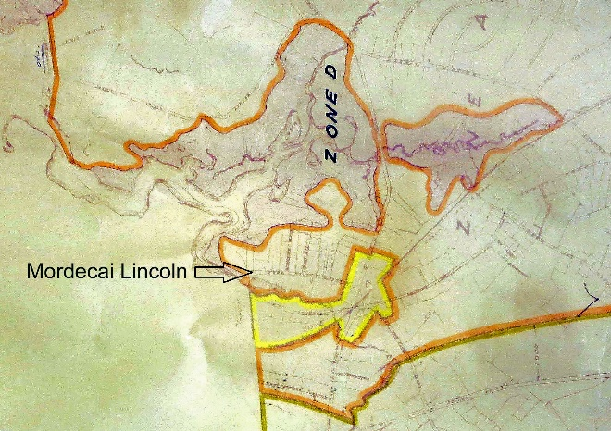  Fig. 1. At North Scituate, Zone D protects shore at the Gulph. Added arrow points to Mordecai Lincoln Road, part of Zone A. | 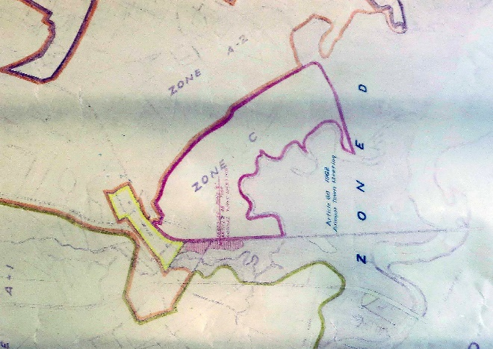  Fig. 2. At Greenbush, irregular rectangular area in center left runs between Country Way at Old Oaken Bucket Pond and First Herring Brook (squiggly line). Now Driftway.
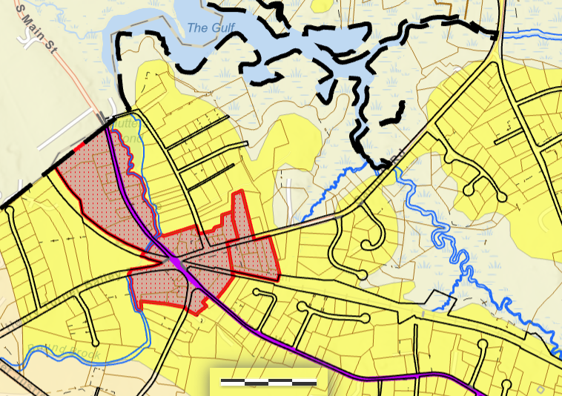  Fig. 3. At center left, Mordecai Lincoln Road with its three-pronged side streets is still in a Residential zone. | 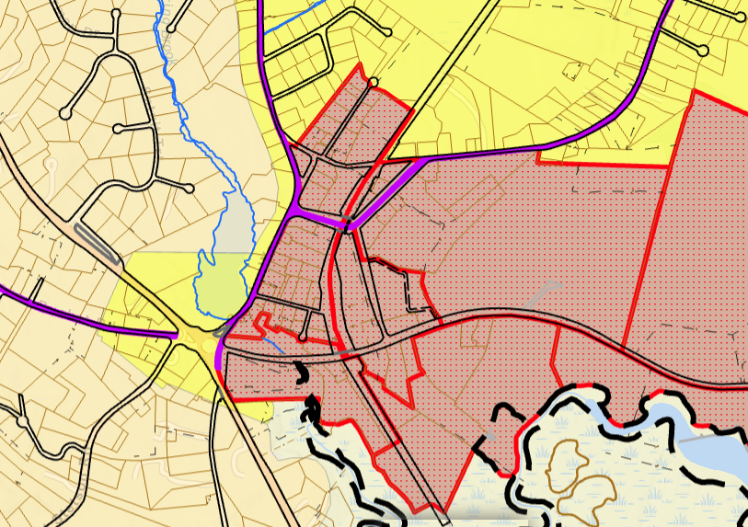  Fig. 4. At Greenbush, irregular rectangular area (business zone) in center merges with former commercial zone.

From this, one can conclude that Scituate’s adopting zoning changes in 1962, adding Zone D, protected and conserved its seacoast salt marshes, tidelands, and marshlands. Zoning districts today are more complicated, but they preserve those changes from 1962.

Benchmarks and Elevation
Lyle Nyberg, July 1, 2025; revised Sept. 2

I like to know where I am and where I am going. Geographically, I mean. You may use GPS. Not me. I use my memory (my “internal GPS”) developed from years of traveling, getting lost (or not), and reading maps. Maps fascinate me.

So I was intrigued to discover, in my town’s archives, a book of maps from the Massachusetts Geodetic Survey (MGS) from the 1930s. They show locations of benchmarks placed in 365 cities and towns. Benchmarks establish location and elevation (height).

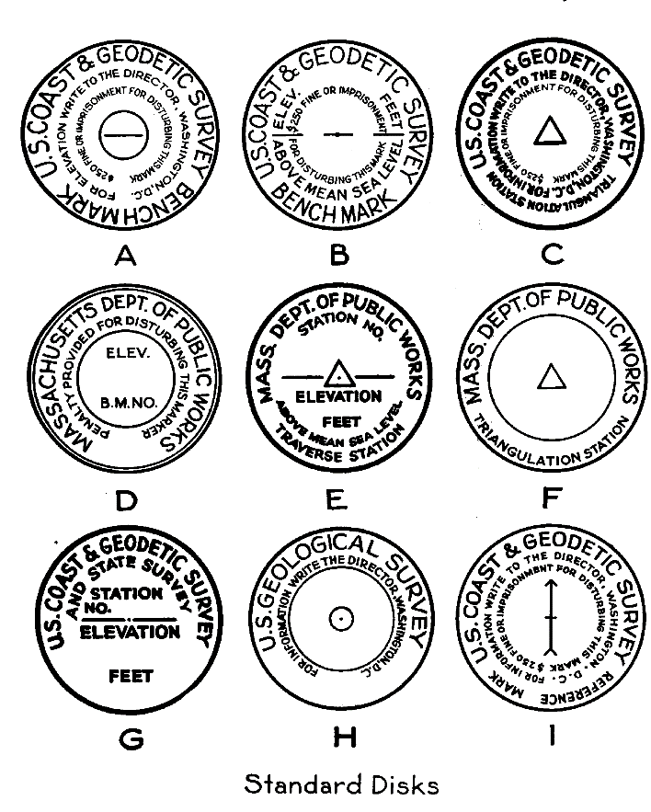
Fig. 1. Benchmark disks, MGS report, 1940.

This book, which is about 8 ½ by 7 ¼ inches, raises questions. What does “geodetic” mean? How rare or important is it? How did it come about? And where are these benchmarks now?

“Geodetic” derives from the Greek word “geodaites” connoting the measurement of the shape and size of the earth. A Greek, Eratosthenes, is considered the father of geodesy, and he coined the term geography. My late brother-in-law Manny, who was Greek, would tell you that Greeks invented everything. Perhaps not Global Positioning System (GPS) devices, which now use satellites to locate our place on this earth.

In modern terms, a geodetic survey establishes the position of fixed reference points on the Earth's surface, perhaps in terms of longitude and latitude. The points can be marked by benchmarks. Sometimes they are chisel marks on boulders, sometimes metal disks embedded in concrete (as shown above). They can be above ground or below ground or flush with the ground. They are sometimes spelled as “bench marks,” and sometimes abbreviated as “BM.” Benchmarks mark a point of known horizontal location and elevation.

Massachusetts played a key role in surveying America and establishing benchmarks. As noted in my book, On a River: A History of North River, Massachusetts, Boston was the hub of the hydrography universe after the Civil War, home to scientific experts and state and federal agencies devoted to mapping America’s shores and lands. Cartographic historian Joseph G. Garver noted that during this time:

One of the first projects of the [US] Geological Survy was its cooperation with the State of Massachusetts and the [US] Coast Survey in the topographic mapping of the state in its entirety at a scale of 1:62,500 … Many other parts of the country were being surveyed simultaneously – in a variety of scales – but Massachusetts was the first state to be completely mapped.

The value of the 1930s book varies. For a map lover and historian, the book is interesting. For a land surveyor, the information is probably outdated. Besides, the survey separately published more exact descriptions of where the benchmarks were, and the descriptions are available on the internet. Still, there is historic value here, perhaps informing us in a world of climate change and sea level rise.

First, the 1930s book had a large geographical scope. Today, land surveyors often measure particular plots of land, or perhaps a large property development. But the 1930s book resulted from surveying the entire state.

Second, surveying and marking elevation raises a basic question: elevation above what? The basis for measurement is set forth in certain standards (datum). The standards change and improve over time. Often they are based on feet above sea level, or “mean sea level” in technical terms. But we know that sea levels change.

For example, sea levels have generally risen over the last century. So the 1930s book provides a good baseline. In addition, earth levels have changed, up or down, depending on the location. Most large American cities are slowly sinking (subsiding). A recent article based on just-published research reveals that about 34 million people live in these subsiding areas in America, and the article explores the impact.

People living in a coastal community such as Boston may face a double whammy -- sinking land and a rising sea. Elevation matters.

I took a deeper look at the situation along the North River in Massachusetts, where I live, to update my book, On a River: A History of North River, Massachusetts.

In 1870, as discussed in the book, a dam was proposed near the end of the North River. It was near what is now the Sea Street bridge between Marshfield and Scituate’s Humarock beachfront peninsula. There, an 1870 survey made a benchmark on a boulder. I searched for it but did not find it. It may have been lost in the later construction and reconstruction of the bridges there.

In 1915, the river was again surveyed. As the 1915 report noted on page 8:

While various surveys have been made of the North River none of them included soundings throughout the distance covered by the resolve. It was therefore necessary to resurvey the outlines of the river in connection with taking the depths. In preparing the map of the river we have, by the courtesv of the Boston office of the United States Engineer Corps, utilized the contour lines shown on the maps made by them in 1910. We also used the same datum plane and checked on several of their bench marks.

The 1915 resurvey did not seem to use the 1870 benchmarks. However, it installed additional benchmarks.

Massachusetts Geodetic Survey

In the 1930s, the Massachusetts Geodetic Survey (MGS) surveyed most or all cities and towns of the state. It was organized in December 1933 under the state Department of Public Works (DPW). DPW and other organizations had previously performed work “to place elevations in Massachusetts on a mean-sea-level datum by means of spirit leveling of high precision.” The MGS extended “its network of levels to include bench marks recognized as part of other systems of leveling,” including those of the US Coast and Geodetic Survey. By 1936, more than 2,300 benchmarks were published in the MGS report, Bench Marks in Massachusetts 1936, Volume III.

As is typical, workers established fixed stations, made sight lines creating triangles, and then triangulated from there to cover the area. The DPW reported modest costs for this work as miscellaneous or maintenance expenses.

By 1936, there was federal support for this work. The DPW said in its 1936 report:

During the year the Massachusetts Geodetic Survey, which is a Works Progress Administration project sponsored by the Massachusetts Department of Public Works, has made level, traverse, and triangulation surveys, and has established bench marks, traverse and triangulation stations as follows:
480 miles of first order levels.
960 miles of second order levels.
1820 bench marks.
590 miles of second order traverse, including
870 monumented stations.
130 triangulation stations.
50 magnetic stations.

The benchmarks and other work kept coming. In 1937, the DPW reported “103 new town and city maps were drawn and 110 town and city maps were redrawn.” This is what led to the published book of maps. In 1938, the DPW reported that an additional 1,379 benchmarks were established; 83 new maps were drawn; and 82 maps were redrawn.

The maps documented existing and historical benchmarks and added more. The work produced a number of additional documents. The MGS issued monthly bulletins.

For example, a 1938 report noted benchmarks from 1915 in Scituate on Front Street, including:

a copper plug set in the concrete wall of the new city dock near Welch’s Coal Wharf. Elevation: 14.98 feet above mean low water; 10.48 feet above half tide level; 5.98 feet above mean high water.

The document recorded elevations on other benchmarks in Scituate after 1915. Many of these were on seawalls, which have historically been destroyed by ocean tides and storms, such as the Blizzard of 1978.

Despite the storms, the Massachusetts Geodetic Survey of the 1930s provides good historical data for elevations of Massachusetts coastal towns experiencing sea level rise, as well as inland towns facing increased flooding caused by climate change.

Why is this important? Historical data gives us measures of environmental change and its likely effects for us.

In addition, measures from the 1930s are important because much of the increase in sea level rise has occurred in the last 100 years.

Boston and other coastal communities are facing sea level rise and perhaps subsiding land. Massachusetts is fortunate to have extensive historical data on elevations, even though some benchmarks can no longer be found. Data from early surveys will be helpful for Massachusetts communities in responding to these environmental challenges.

As I said, I do not use GPS and I do not use surveyor benchmarks. My benchmarks, as you can see in the book, are places for food, such as Previte’s in Hanover and the Bridgewaye Inn in Marshfield. As for finding the old benchmarks, I will leave that to others. Probably. Maybe we can revive the practice of geocaching, with adventures in locating these places.

Great Green Island Remnants
Bill Richardson email, May 12, 2025

Hi Lyle,

Your “On a River” got me interested in the disappearance of Great Green Island, which is fascinating. It motivated me to compile this set of maps and photos in an attempt to trace the Island's history. Most of these images are taken from figures in your “On a River”. Some are from coastal navigation and USGS maps. A few are markups recent aerials that Gary and I have taken.

They are arranged in chronological sequence, illustrating how the location of Great Green has changed since 1898. By comparing the charts to recent air photos, I believe that the Island's vestigial remnants can still be found in the rocky shoal and sand bar located behind Fourth Cliff.

In fact, the remnants of Great Green may show up in the extreme upper right-hand corner of “On a River’s” cover photo:
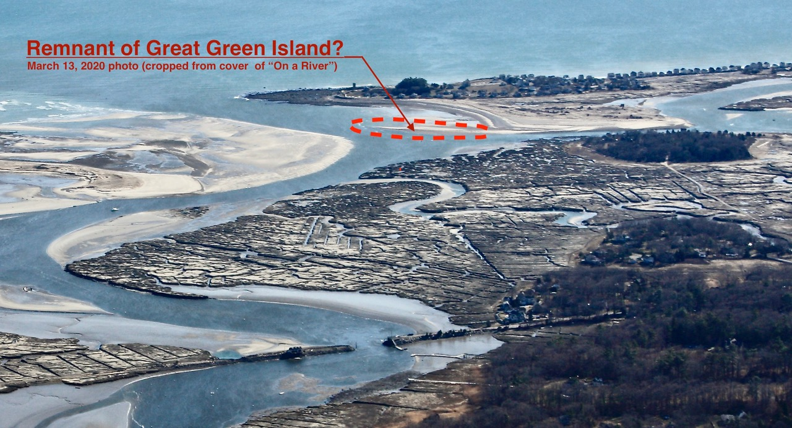

1. The sequence of maps and charts showing the migration of Great Green Island begins with the 1831 Robbins map (Fig. 96 - “On a River”):
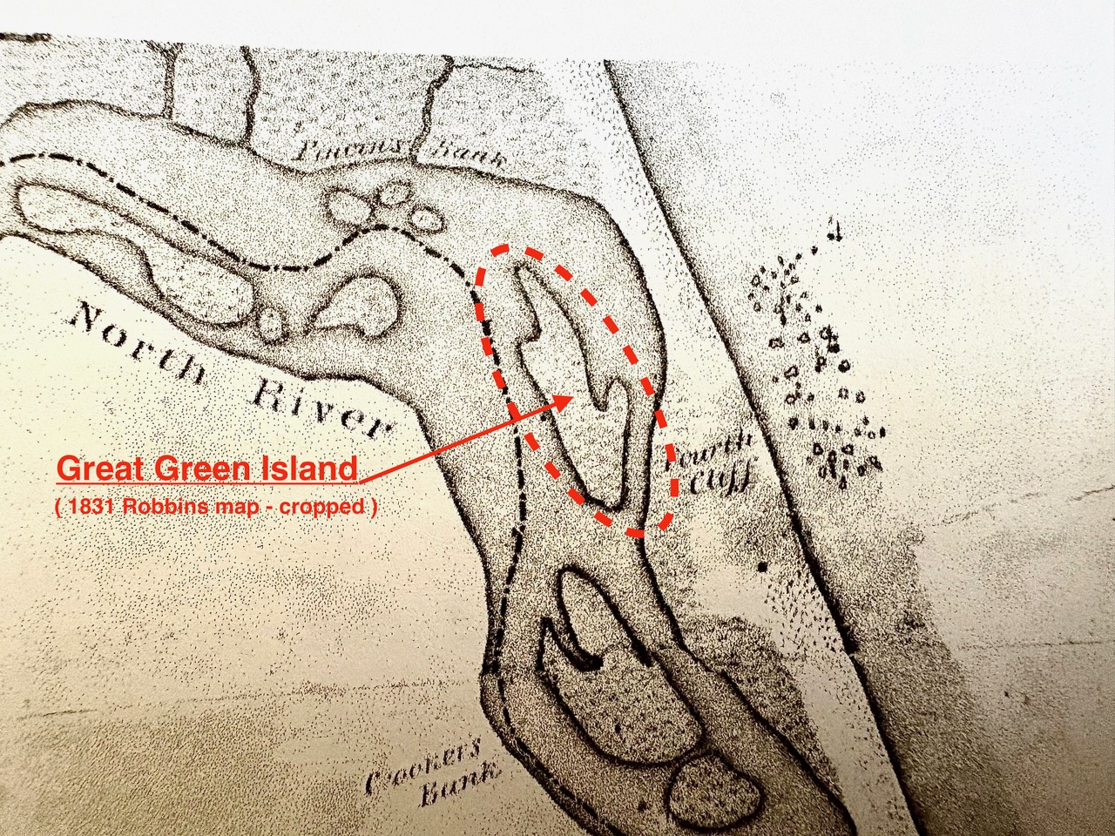

2. Meteyard’s watercolor view (Fig. 111 - “On a River”) shows what appears to be Great Green Island (prior to the 1898 storm):
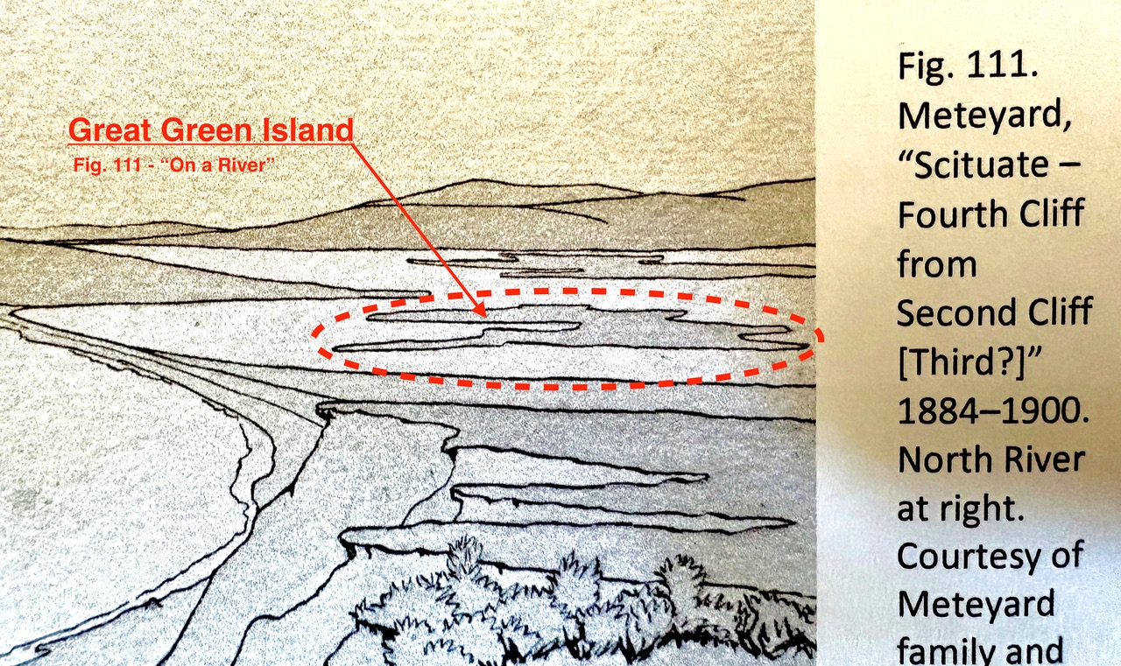

3. The 1898 (?) Harbor & Land Comm “Plan of the Mouth of North River Scituate” shows a marsh remnant at the location of Great Green Island:

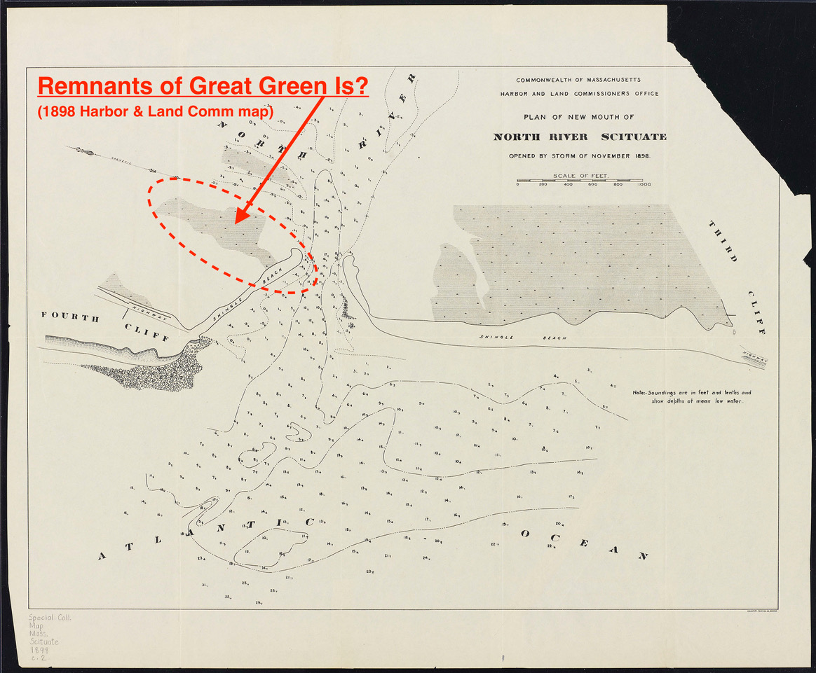

4. The 1902 Coast & Geodetic Survey chart (Fig. 107 - “On a River”) shows what may be a shoal at the former location of Great Green:
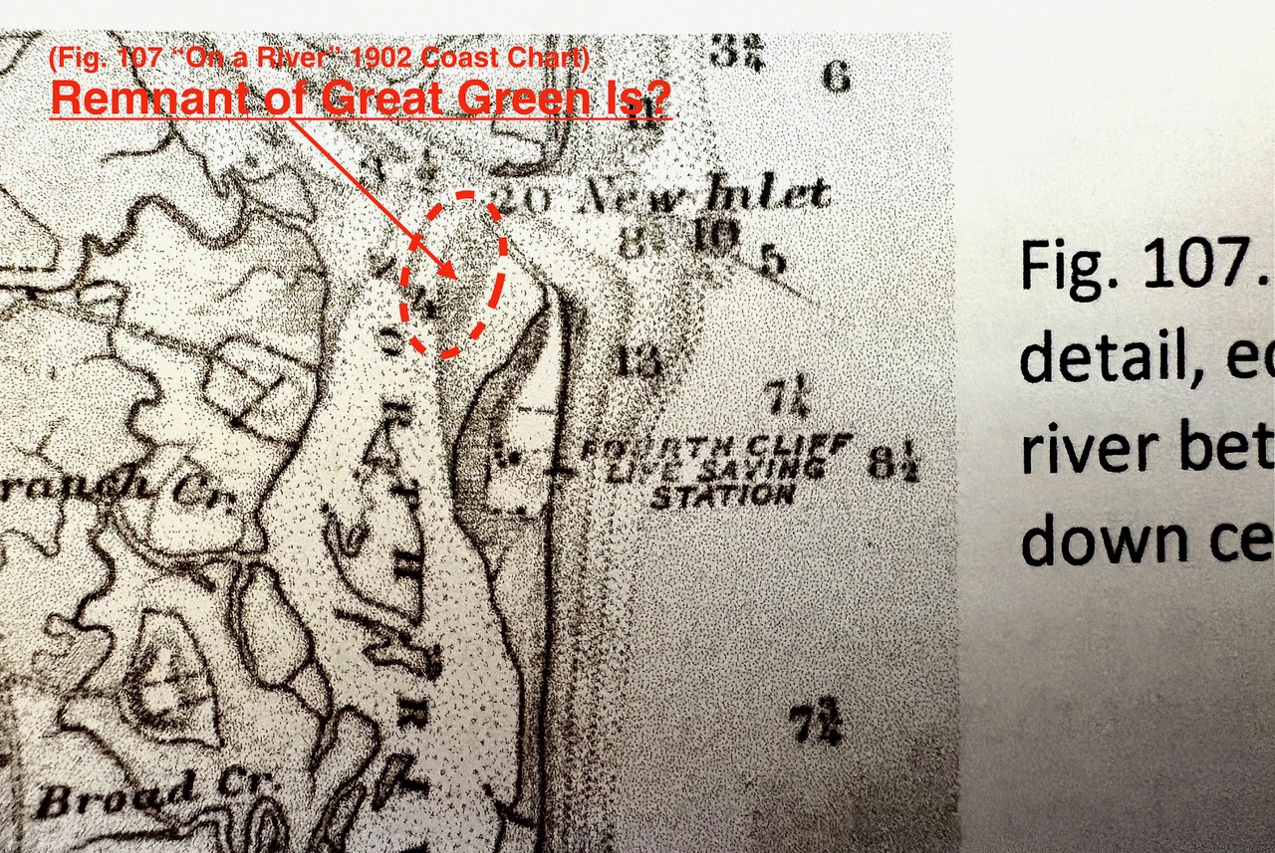

5. The 1915 Harbor & Land Comm chart ( Fig. 114 - “On a River”) shows a shoal at the former location of Great Green Island:
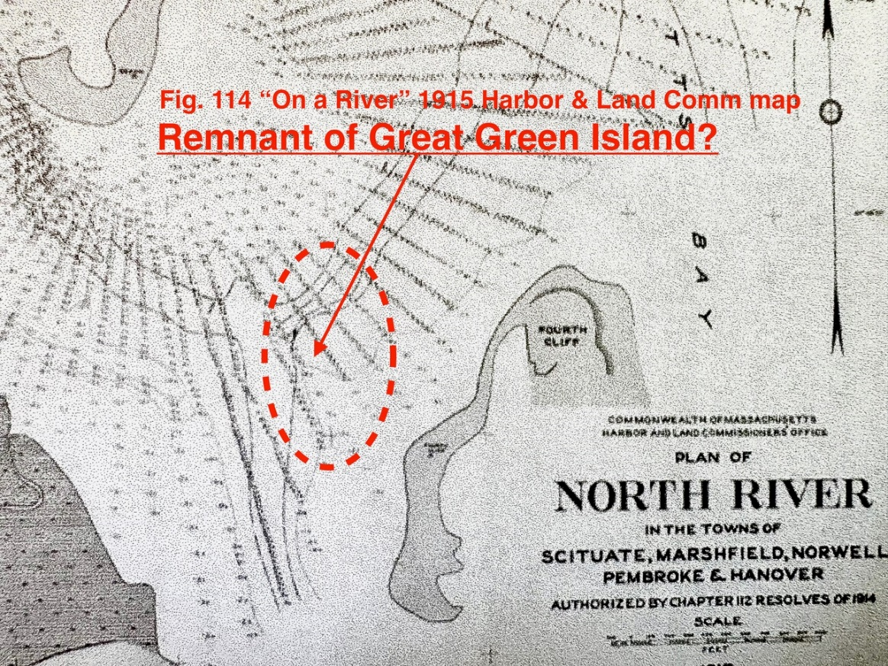

6. The 1997 NOAA Coast & Geodetic Chart 13267 denotes “rky” and “Shl rep 1975” and shows “S” and “M” (sand and mud) at the former location of Great Green Island:

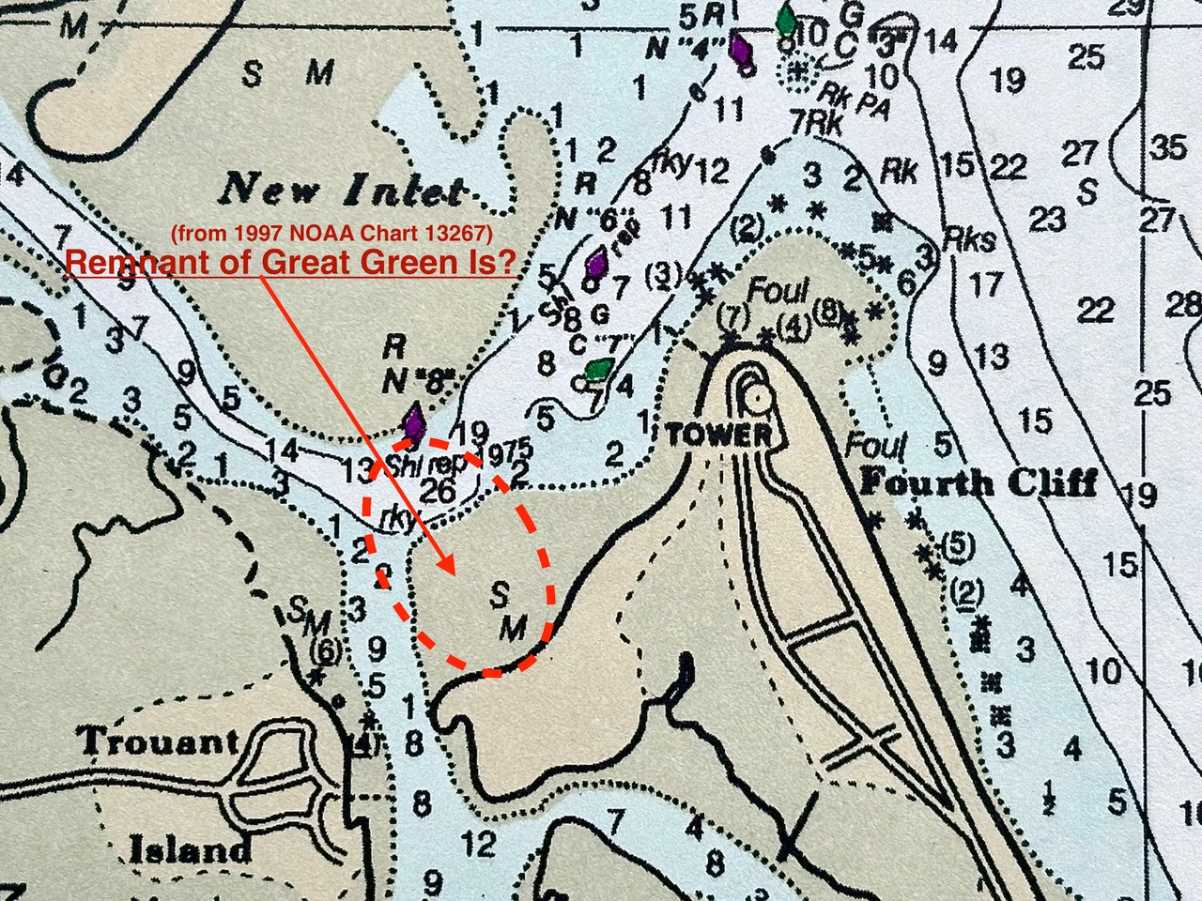

7. This 2018 aerial shows the sand and mud shoal behind 4th Cliff, plus the rocky bottom (noted above), at the former location of Great Green Island:
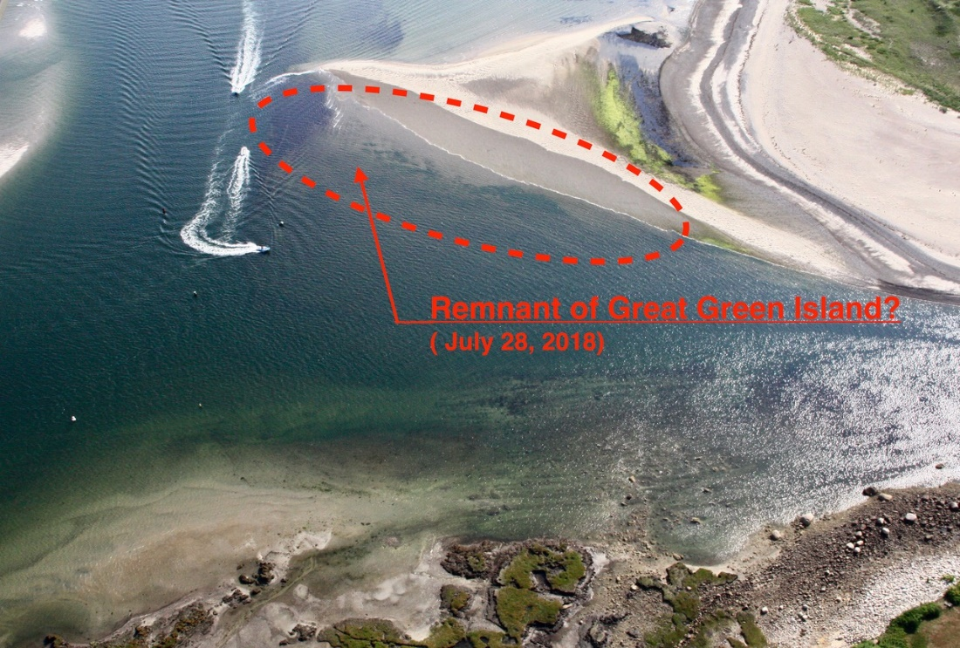

8. This May 1, 2013 aerial provides an overview of the North River spit, looking south, which shows the sand and mud shoal behind 4th Cliff that may be the rocky remnant of Great Green Island:
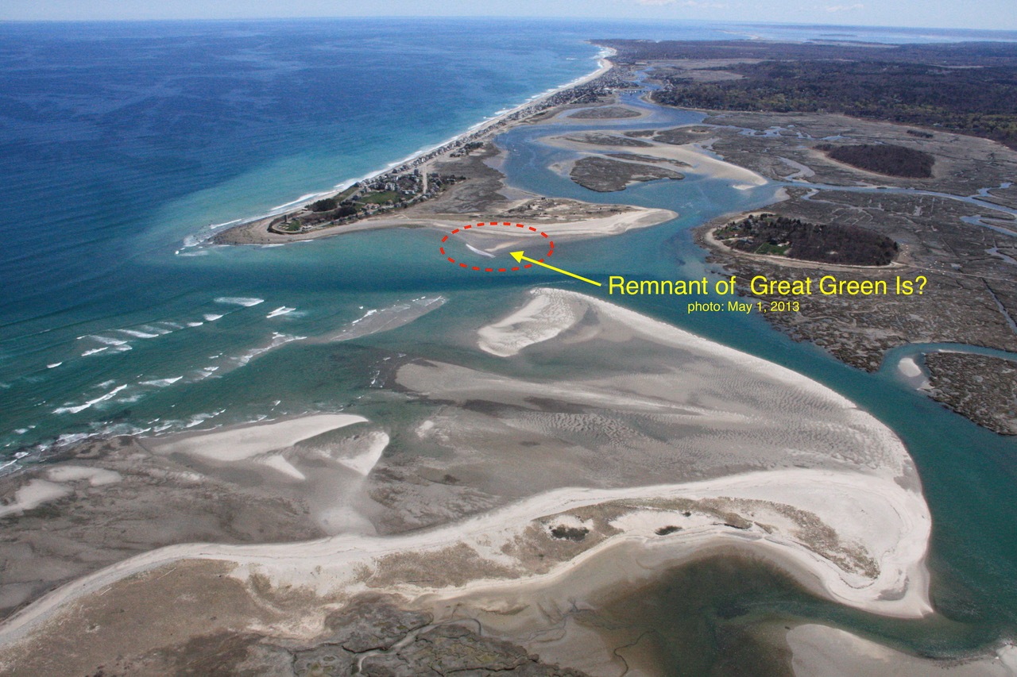

SO . . . it may be that the bones of Great Green Island still lurk in the rocky shoal behind the 4th Cliff spit. I think Great Green has morphed into the rocky shoal and sand bar that lies just east of the entrance buoy to the South River.

Maybe . . . . ?
A fun puzzle!

Best regards,
Bill

**

“AIP Members in Armed Forces of the United States,” Journal of the American Institute of Planners, 9:1, 37 (1943), https://doi.org/10.1080/01944364308979045; for example, see “Comprehensive Plan, 1964 Worcester Massachusetts,” i (Benjamin), 71-84 (discussion of land use), 229- (official map adopted 1953, zoning ordinances in 1924 and 1963), https://www.worcesterma.gov/planning-regulatory/document-center/worcester-master-plan-1964.pdf. The Scituate Planning Board reported, “The Board desires to express its appreciation of the technical assistance of Mr. Benjamin, whom we believe has given us services considerably beyond his remuneration.” Town of Scituate Annual Report for 1953, 110, 146, https://archive.org/details/annualreportofto1952scit/page/n471/mode/2up?q=%22allen+benjamin%22.
Town of Scituate Annual Report for 1940, https://archive.org/details/annualreportofto1940scit/page/n9/mode/2up?q=zoning.
On a River: A History of North River, Massachusetts (Scituate: Lyle Nyberg, 2025), 220-221; Mark Monmonier email, June 16, 2025.
“Silent Spring,” Wikipedia article, https://en.wikipedia.org/wiki/Silent_Spring; Town of Scituate Annual Report for 1962, 34-36, https://archive.org/details/annualreportofto1961scit/page/n323/mode/2up?q=%22zone+d%22. The article targeted areas north of the North River, and areas south of Cohasset Harbor, to points “of ten (10) feet elevation above mean low water mark” as shown on a USGS map.
“Planning Board Recommends Zoning Articles,” South Shore Mirror, March 1, 1962, 13, and 10 (League of Women Voters endorsed zoning change).
“Town of Scituate, Massachusetts, Zoning Map, October 25, 2011, revised April 8, 2019,” original by Amory Engineers, P.C., revision by Dodson & Finker, Inc., https://www.scituatema.gov/sites/g/files/vyhlif11836/f/pages/tc_filed_current_zoning_map.pdf; “Zoning Bylaws, Town of Scituate, Massachusetts,” posted July 2024, section 300, https://www.scituatema.gov/buildinginspections-department/pages/zoning-bylaw. See also “Town of Scituate, MA GIS Viewer,” updated August 5, 2024, layer for Zoning Map, https://www.arcgis.com/home/item.html?id=c98fdc777a664770817634de44ba1188.
Remember GPS handheld devices from Garmin, founded in 1989? “Garmin,” Wikipedia article, https://en.wikipedia.org/wiki/Garmin. Remember geocaching using GPS devices, starting in 2000? “Geocaching,” Wikipedia article, https://en.wikipedia.org/wiki/Geocaching. Some geocaches have been extraterrestrial.
Standard benchmark disks are shown in Massachusetts Geodetic Survey, US Work Projects Administration (Mass.), Adjusted bench marks in the counties of Plymouth and Barnstable, Part I: Plymouth; A summary of all descriptions and elevations as of September 1940 (Boston, 1940), 3 [11/256], https://catalog.hathitrust.org/Record/001513741.
“Eratosthenes,” Wikipedia article, https://en.wikipedia.org/wiki/Eratosthenes.
See John R. Stilgoe, Landscape and Images (Charlottesville, VA: University of Virginia Press, 2005), chapter “Jack-o’-lanterns to Surveyors: The Secularization of Landscape Boundaries”; Mark Monmonier, Coast Lines: How Mapmakers Frame the World and Chart Environmental Change (Chicago: University of Chicago Press, 2008, updated edition).
Nyberg, On a River, 101-106; Joseph G. Garver, Surveying the Shore: Historic Maps of Coastal Massachusetts, 1600-1930 (Beverly, MA: Commonwealth Editions, 2006), 112 (quoted).
Past publications include (thanks to Bill Keegan), listings on “Massachusetts Geodetic Survey,” Online Books, https://onlinebooks.library.upenn.edu/webbin/book/lookupname?key=Massachusetts%20geodetic%20survey; Status of Land Surveying in Eastern Massachusetts ([Boston]: Massachusetts Geodetic Survey, Work Progress Administration [Mass. Project No. 428], 1936), https://archive.org/details/statusoflandsurv00usma/page/n7/mode/2up; MGS, Geodetic Bulletin: a Monthly Compilation of Geodetic Data: Partial Listing of Descriptions And Coordinates of Traverse And Triangulation Stations In Sections of Massachusetts (Boston: Massachusetts Geodetic Survey), 1938-1941 online and listed, https://catalog.hathitrust.org/Record/002133992.
Kasha Patel and Naema Ahmed, “Land under the country’s largest cities is sinking. Here’s where — and why.,” Washington Post, May 8, 2025, https://www.washingtonpost.com/climate-environment/2025/05/08/sinking-land-cities-inland-infrastructure-damage/
Lyle Nyberg, On a River: A History of North River, Massachusetts (by author: 2025), 131-132.
MGS, Bench Marks in Massachusetts 1936, Volume III, ([Boston], 1936), WPA Project No. 428, iii, vii, viii, https://catalog.hathitrust.org/Record/001513739.
For example, see MGS map, sheet 44, Boston (West Roxbury 9), U.S.C. & G.S. and State triangulation station Belle 1933, bottom center, and sheet 45, Boston (Hyde Park 10), triangulation station 15Z 1934, left side; Fifteenth Annual Report of the Department of Public Works, Year Ending November 30, 1934 [“DPW report”] (Boston: Commonwealth of Massachusetts, 1934), 28, State Library of Massachusetts, http://archives.lib.state.ma.us/handle/2452/799345. Copies of some MGS maps are available on author’s website, https://benchmarks.lylenyberg.com/.
DPW report for 1936, 19, http://archives.lib.state.ma.us/handle/2452/799347.
DPW report for 1937, 23, http://archives.lib.state.ma.us/handle/2452/799348; DPW report for 1938, no page number given, http://archives.lib.state.ma.us/handle/2452/799349.
See note 11 above.
State of Massachusetts and Dept. of Commerce, U.S. Coast and Geodetic Survey, Tidal bench marks, state of Massachusetts. (Boston: Mass. Geodetic Survey, 1938, reissued), 41-42, https://catalog.hathitrust.org/Record/001273625. The MGS updated these benchmarks in its 1940 report, 180-191 [190-201/266], including tidal benchmarks.
Nyberg, On a River, particularly ch. 12 “Coastal Wetlands Research,” with discussion of National Estuarine Research Reserves sites, including Massachusetts.
See Talke, Kemp, Woodruff 2018 paper cited in note 410 of Nyberg, On a River.

