On a Cliff: A History of Third Cliff in Scituate, Massachusetts (2021)
Corrections and Additions
Available at https://www.lylenyberg.com/corrections-and-additions

Chronology of Revisions:

December 6, 2021:
12/6/2021 (page 251, note 9)
12/27 (162; 194)

January 1, 2022 (213)
1/2 (31)
1/6 (279, note 338)
1/19 (275, note 300; 280, note 353)
2/16 (315, note 785)
3/21 (287, note 439)
3/28 (205-206)
4/8 (268, note 213)
4/9 (50; 268, note 216)
4/19 (285, note 423)
4/25 (259, note 112)
6/9 (279, note 338)
7/19 (251, note 4)
7/23 (259, note 106)
7/24 (84)
7/26 (266, note 199)
8/7 (257-258, note 89)

January 18, 2024
1/18 (201)

July 12, 2025
7/12 (218-219)

July 22, 2025
See note below at end on George F. Welch and his granddaughter Frances Johnson

August 17, 2025
See note below at end about Danger sign where Driftway meets Collier Road.

January 2, 2026
See note below about note 378.

January 26, 2026
Add text below after 211 with more about Mary Jane MacKenzie.

Below are corrections and additions to the version of December 6, 2021, or later, of On a Cliff. Some may have been incorporated in later paperback versions of the book available on Amazon. References are to page numbers except as noted. The index has generally not been updated. Please let me know of any more corrections or additions.

Text
- 31. Add paragraph before “It is fascinating …”: Scituate was famous in 1880 for a cow: “The most famous living butter cow today is ‘Jersey Belle of Scituate,’ the property of Mr. C. O. Ellms, of Scituate, Mass., dropped in 1871, and bred by Mr. E. D. Sohier. She is now nine years old …” per “The Jersey Belle of Scituate,” The American Agriculturist, vol. 39 (New York: Orange Judd Company, June 1880), 225 (with photo), https://books.google.com/books?id=RRhOAAAAYAAJ&newbks=1&newbks_redir=0&source=gbs_navlinks_s.
- 50. Change “(about 20)” to “(about 23)”.
- 84. For a deeper understanding of the marshes and their ditches, see materials collected on author’s website at Ditches tab, https://www.lylenyberg.com/copy-of-seacoast-by-air.
- 162. Delete reference to “the ‘Barn,’” which was owned by other nearby artists. See 19thCenturyArtColony.org website cited in note 600.
- 194. Change photo credit to Donald Ledwig. Change caption to “Herbert G. and Nell Perry and their daughters, from left: Meredith Perry Wilcox Lowder, Eleanor Perry Beal, and Elizabeth Perry Spurr. In porch on Michael Avenue side of Third Cliff home, c. 1960s. Photo by Donald Ledwig. Courtesy of Donald Ledwig and Jack Spurr.”
- 201. Change paragraph to read “On nearby Fourth Cliff, the US Army installed a coastal artillery site with 6-inch guns and associated radar units. Some of the military installation still exists, including a five-story concrete tower.” 16-inch guns were proposed but never installed.
- 205-206. Add “Robert Allan summarizes growing up in these post-war years as follows, in an email March 27, 2022:

I moved to 71 Gilson Rd at about 1 year old in 1953 and grew up there until I left the area after graduating from Massachusetts Maritime Academy in 1974. My parents Robert and Elaine (Jackie) Allan resided there until @ 1994 or 1995. We were close friends with George and Doris Hauman and she cultivated a love of art and handicrafts with me as a child. As an enterprising young lad, I worked at Scituate Country Club as a green's keeper's helper, had my own lawn mowing business and as a 10 or 11 year old I would go down at low tides and collect Irish moss in burlap bags and bring them back up the cliff to be taken down to the harbor for sale to Mr Rouseau for $.02/lb. My mother was a special education teacher in the Scituate elementary school system and was well known through out Scituate. ... It was an amazing place to be a kid!

- 211. Add this, from former resident Marjorie Bradley Kellogg in an email 1/26/26:

Mary Jane MacKenzie called her boat the Tangerine Seagull. For a while, she had a pair of herring gulls who would come to the stone wall bordering her yard to be fed by hand. She called them Lady and Winston Churchill. She did indeed wear baggy workman's clothing, all year round...except on Election Day, when she would go to vote in her tweed skirt and without the cheesecloth mask that she wore to preserve her complexion (which seemed to work). Her little house was a topic of wonder and rumor among the kids, a perfect model for a witch's lair (we said), crammed with bird's nests and stones and shells, plus other keepsakes, but she was always welcoming when we came by. She liked to show us things she'd found along the beach, and sometimes there were donuts. I knew even then that there was something remarkable about her, not just her eccentricity. A woman ahead of her time.

- 213. Change quote in lines 3-4 to “if a car went by, everyone ran to the windows.”
- 218-219. In an email June 12, 2025, Bruce Beagley added these details:

Although I’ve read “On a CLIFF”, some how I missed the reference to the neighborhood golf tournament. Actually, I think we held it a couple years on July 4th…following the Hat Parade. Each competitor was given three plastic golf balls and initialed them with a Sharpie. Hitting a strategically placed target was required to complete a hole. A couple years ago, we had some major landscaping done in the backyard and I found one of those balls, lost for twenty five years. Incidentally, the 4th of July Hat parade…reportedly a tradition dating back to the 1800s, was John Messenger’s idea. John grew up in a small town in Indiana which held a hat parade every 4th.

Endnotes
- 251. Note 4. This is part of a three-volume work that is available on the web. Jeremy Dupertuis Bangs, The Seventeenth-Century Town Records of Scituate, Massachusetts, three volumes (Boston: New England Historic Genealogical Society, 1997, 1999, 2001), https://catalog.hathitrust.org/Record/010029242.
- 251. Note 9. For a detailed description of the geology and landscape of the area, see Cap’n Vinal, “The Old Colony’s North River,” South Shore Mirror, February 2, 1961, 17.
- 252. Note 18. For a one-sided view of English settlement from the perspective of 1674, see Francis Baylies, An Historical Memoir of the Colony of New Plymouth: From the Flight of the Pilgrims Into Holland in the Year 1608, to the Union of that Colony with Massachusetts in 1692, Volume 2 (Boston: Wiggin & Lunt, 1866), 2, https://books.google.com/books?id=PxxEAQAAMAAJ&source=gbs_navlinks_s: “After the aboriginal title had been extinguished, the English settlers first occupied that part of the Indian country which had been depopulated by the pestilence, and here were situated the towns of Plymouth, Duxbury, Scituate, and Marshfield, on the coast, and Taunton, Rehoboth, and Bridgewater, in the interior.” For a more nuanced historical view, see Mark Jarzombek, “The “Indianized” Landscape of Massachusetts,” Places Journal, February 2021, https://placesjournal.org/article/the-indianized-landscape-of-massachusetts/, and https://doi.org/10.22269/210209.
- 257-258. Note 89. After the 1803 act, the town voted to petition the state legislature for a further act with more detailed requirements for the “floodgate” and mill dams; record of Scituate Town Meeting, May 2, 1803, vol. C-8B, 62 ½, 64, Town Archives.
- 259. Note 106. The 1898 storm did not finish plans for navigation through this area. As reported in Joseph Foster Merritt, Old Time Anecdotes of the North River and the South Shore (Rockland, MA: Rockland Standard Publishing Company, 1928), 35, https://catalog.hathitrust.org/Record/010027973:
“In 1910 the Engineer Corps of the United States Army made a partial survey of the river in connection with a plan for an inland waterway from Narraganset Bay through Taunton River, by canal to North River, thence to Boston. The survey was never completed and the idea was abandoned.”
- 259. Note 112. The Archdiocese had previously proposed a project for low- and moderate-income housing, which the town denied. Town of Scituate zoning board of appeals, May 24, 1973, Elmer C. Bartels Papers (MS 817), Special Collections and University Archives, University of Massachusetts Amherst Libraries, https://credo.library.umass.edu/view/full/mums817-b002-f040-i021.
- 266. Note 199. Growing and harvesting seaweed seems to be on the rise in America. See Kathy Gunst, “Seaweed helps Maine lobstermen ride the storm of climate change,” Washington Post, July 25, 2022, https://www.washingtonpost.com/food/2022/07/25/seaweed-maine-lobster-industry/.
- 268. Note 213. The “D. Ward” was probably Dennis Ward (1802-1866), a property owner listed in tax valuation lists for years including 1851 to 1855. Dennis acquired the property in 1849, about the same time that Daniel Ward built his twin house at the northern end of Third Cliff. Dennis’s property was at the southern end, two acres and a later homestead. Samuel H. Turner to Dennis Ward, deed, Sept. 3, 1849, PCRD, book 234, page 156. Dennis Ward appears to have been the brother of Daniel Ward, based on US census records, and town death records. The 1857 Walling map of Plymouth County indicates the property was at what is now 8 Driftway. Deeds mention the “falls,” which could have been at this location. This was later the J. Donahoe farm shown on the 1879 Walker map, a detail of which appears on page 50 in this book. In 1866, Dennis conveyed this Third Cliff property to his sons Hugh and Daniel. Dennis and Cecilia Ward to sons Hugh Ward and Daniel Ward 2d, April 28, 1866, PCRD, book 334, page 225. Dennis Ward died that same year, 1866, in Scituate. Massachusetts Secretary of State Vital Records online; Town of Scituate death records, vol. 19, 1862-1904, 11 (Dennis), 47 (Daniel); see “Dennis Ward,” FindAGrave memorial, https://www.findagrave.com/memorial/107650659/dennis-ward.
- 268. Note 216. In last sentence, change 20 to 23, and add at end: “, D. Ward [Dennis Ward], and Dennis Ward’s sons Hugh and Daniel 2d.”
- 276. Note 300. The full citation is Pamela L. McCallum & Nancy M. Young, Memories of The Cliff Hotel (Scituate, MA: Converpage, 2012).
- 279. Note 338. According to a January 5, 2022, email from Jim Glinski, long-time Damon’s Point resident Walter E. Crossley wrote a series of articles for the Marshfield Mariner in 1972–1973 that included this: “In reply to a call the other day, I will say that the ditches in the marsh were not dug by the mosquito control. They were dug many, many years ago for drainage purposes to enable the farmers to cut and gather hay. Imagine the hours of labor that went into these miles of ditches all dug by hand tools and plain man power.” See also Galluzzo, The North River, 30-38 and citations/quotes from Vinal, Salt Haying in the North River Valley; Kezia Bacon, “Salt Haying on the North and South Rivers,” NSRWA website, posted April 22, 2008, https://www.nsrwa.org/salt-haying-on-the-north-and-south-rivers/. (ditches dug for boundaries and to dry out marsh to make it easier to mow salt marsh from land). Ditching today is viewed as having damaged the marshes, and there are efforts to remediate them. Daniel Wolff & Dorothy Peteet, “Why A Marsh,” Places Journal, May 2022, ch. 10, https://placesjournal.org/article/the-deep-history-and-uncertain-future-of-a-marsh-on-the-hudson/; David M. Burdick, et al, “Mitigating the Legacy Effects of Ditching in a New England Salt Marsh,” Estuaries and Coasts (November 2020) 43:1672–1679, https://doi.org/10.1007/s12237-019-00656-5; Hope Kelley, “Helping nature heal itself at the Great Marsh,” U.S. Fish and Wildlife Service Northeast Region website, posted January 6, 2016, https://usfwsnortheast.wordpress.com/2016/01/06/helping-nature-heal-itself-at-the-great-marsh/. Salt marsh ditches of the Northeast are mapped here: Northeast Conservation Planning Atlas, “Salt Marsh Ditches, Version 3.0, North Atlantic U.S. Coast,” Data Basin website, posted March 12, 2019, https://databasin.org/datasets/8b04346487a8457d98feea228d9b0275/.
- 280. Note 353. The full citation is David Ball, To the Point: The Story of Scituate Light and Cedar Point (n.p.: David Ball, 1994, 6th printing, 2000).
- 282. Note 378. In the sentence “George Welch had already sold lot 41 (18 Collier) in 1905 and a house may have been on that site as early as 1900” change “sold” to “bought.” Sarah E. Young to George Welch, deed, December 30, 1905, PCRD book 926, page 464. A referenced deed from Sarah and Rodney Moore to Sarah Young was not found as having been recorded.
- 285. Note 423. Add the following. Aerial photos of Massachusetts dating to 1951 are in the William P. MacConnell Aerial Photograph Collection (FS 190), Special Collections and University Archives, University of Massachusetts Amherst Libraries, here. Almost 10,000 photos are online. They are organized by county, not searchable by town. But try going here, and click on “Open in Map Viewer Classic.” Excellent quality images. A terrific 1952 photo of Scituate, from the Harbor south, is here. It shows how the Driftway did not provide the most direct access to Scituate Harbor, as it does today.
- 287. Note 439. Antoinette Pray (c. 1856–1946), then of Weymouth, bought additional properties in the early part of the 1900s in Scituate, including on Gilson Road. In 1915 she bought the historic Dr. Isaac Otis house in Norwell. The book by the DAR, Old Scituate (1921), pages 118–120, says she did much to restore the house, which was built about 1723. MACRIS, NRW.39; see also L. Vernon Briggs, History and Genealogy of the Briggs Family, 1254-1937, Vol. II (Boston: Charles E. Goodspeed & Co., privately printed, 1938), 444–445 (lived there with her sister Mrs. Cora Poe, who was born in 1854 and married Henry Augustus Poe in 1876 per vital records), 475, 579, https://archive.org/details/b29825362_0002/page/n5/mode/2up. The house is still there, at 997 Main Street. According to 1943 news reports, Antoinette became “incapacitated by reason of advanced age to care properly for her property.” She died, unmarried, in early 1946. Her obituary said:
Woman Dead. Antoinette Pray Passed Away In West Newton, January 3 In Her 90th Year. Miss Antoinette Pray, for many years a resident of Norwell, died at West Newton on January 3 in her 90th year. Miss Pray resided on Main street in Norwell and removed from that town a few years ago. She was much interested in historical subjects and garden clubs. Her home was one of the most attractive in the town and years ago was used in a pilgrimage of the historic houses of the town. Funeral services were held at Newton on Saturday, January 5 and a number from Norwell attended.
Scituate Herald, January 11, 1946, 8.
- 315. Note 785. Another interesting person, who died in 2018 at the age of 82, was Paul Kelly. He lived on Eagles Nest Road and took frequent walks, usually stopping any neighbor he met to tell them a joke. As I recall him telling me, he worked on traffic signals for the state. Another resident, Jim Bailey, often says “This is the life,” which is a pretty good description of Third Cliff. Many residents walk their dogs around the neighborhood, such as Erika Richardson and her dachshunds.

Index
- [ TBD.]

~

Note on George F. Welch and his granddaughter Frances Johnson
July 30, 2025

After publishing the book, I had the pleasure of meeting other descendants of George Welch. It was the sad death of Michael Welch Johnson that brought us together. We met in July 2022 at the family house at 29 First Parish Road (since sold). They generously allowed me to copy family photos.

There was a photo of the family house from the early 1900s. Parked in front is a car, license plate 9894 from the 19teens. It looks a lot like the Mitchell Little Six owned by Dr. Alexander and discussed on page 168 of the book. It has a medical cross, no doubt to recognize the doctor’s medical work in town. In the front seat is a little girl, perhaps three years old. My guess is that it is Frances Alexander, born in 1913, who would later marry Dr. Harald Johnson.

There was an excellent photo of George Welch in the early 1900s. It is better than his photo at the start of chapter 16. It would have been a great addition to the book, where I called him camera-shy (maybe he was) in note 846.

There was a photo of George and Harriet Welch’s pretty granddaughter, then probably a teenager, Frances Maxfield Alexander Johnson. She was born in the family house in 1913, according to an email from her daughter Susy Robison on July 22, 2025. She later contributed recollections for a Third Cliff history project in 1986 and 1988. See book notes 165, 456, and 754.

There was a photo of Dr. T. Branch Alexander, Marion (Welch) Alexander, their daughter Frances, and Frances’s husband Dr. Harald Johnson at their wedding. Frances died April 23, 2004, according to an obituary in the Scituate Mariner, May 13, 2004, page 10.

Courtesy of the Welch family/descendants, here are copies of these photos, which I have edited a bit [ref. 2016-9 and 2022-7].

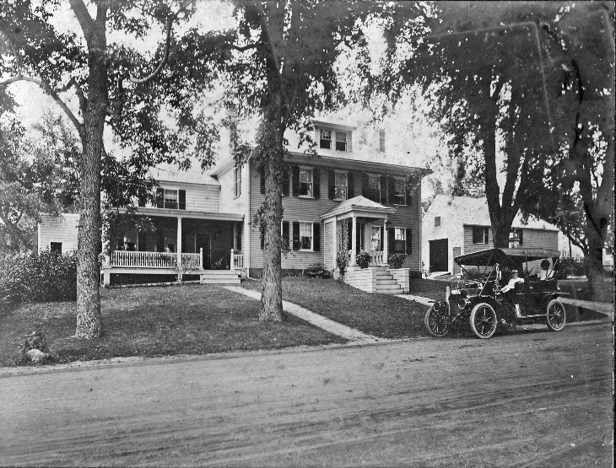  29 First Parish Road, Scituate | 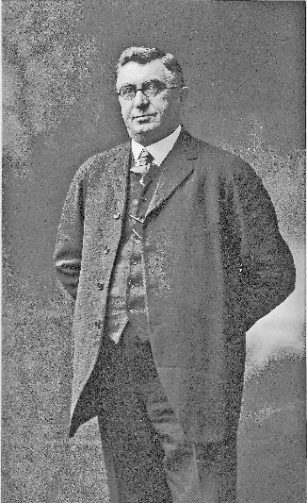  George F. Welch (1859-1931)
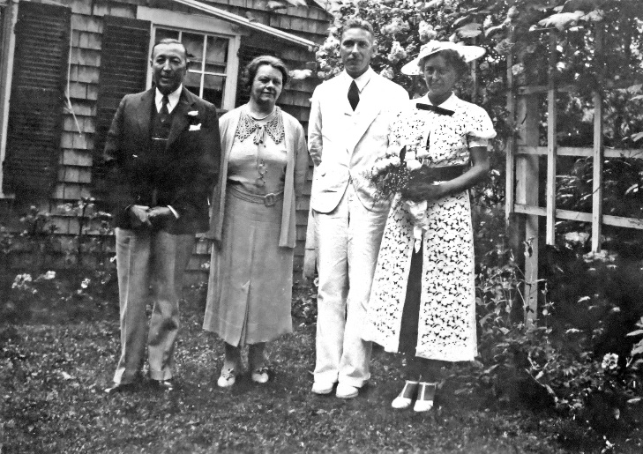  Dr. T. Branch Alexander, Marion (Welch) Johnson, their daughter Frances, and Frances’s new husband Dr. Harald Johnson | 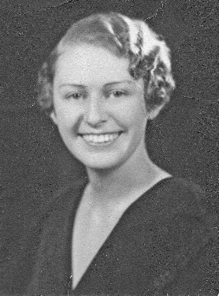  Frances M. Alexander  (teenager?)

Note on Danger Sign, 1923
August 17, 2025

On Jul 7, 1923, the Selectmen approved a Danger sign where the Driftway meets Collier Road. Meyer Bloomfield was a noted lawyer and his summer house was at that intersection, as discussed in more detail in this book and in Summer Suffragists. According to the WPA index cards: “On request of Meyer Bloomfield voted to put sign at Corner of Collier Avenue and Water Street reading “Danger, Enter at your own risk.” It seems the Driftway dropped steeply down the cliff to just above sea level, where it turned toward the end of Third Cliff.

